Clough, Ballee and Downpatrick Non-Subscribing Presbyterian Churches

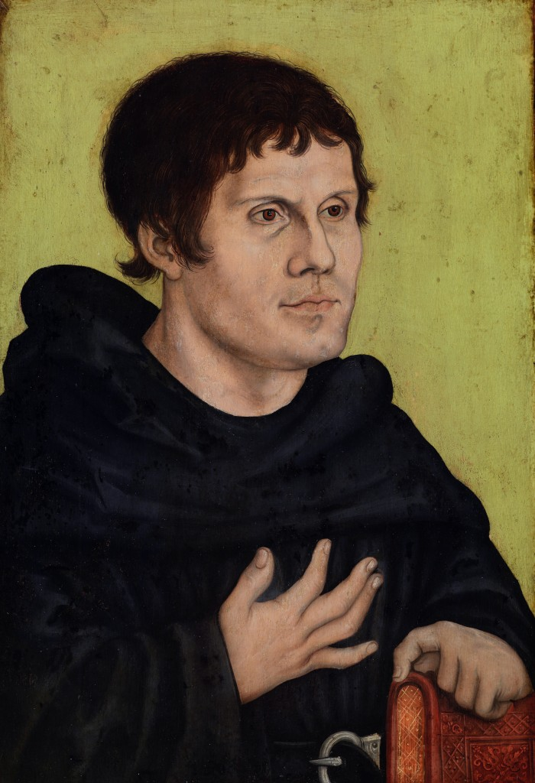

Service and Exhibition to Commemorate the 500th anniversary of the Reformation
Sunday, 29th October at 11.15 am
at Clough Non-Subscribing Presbyterian Church
Preacher: Rev Dr David Steers
Service followed by refreshments
Everyone Welcome

